**PHP Lab** **2**

1- Create an array that contain values (PHP, HTML, CSS, JavaScript)

2- Print the array elements using loop (2 ways)

3- Create an associative array called Info according to the following -Please add your info-

Name

age

Email

Collage

4- Print all the data in HTML Table like above.

5- Write Function to transform data type from integer to string value you give it when you call function.



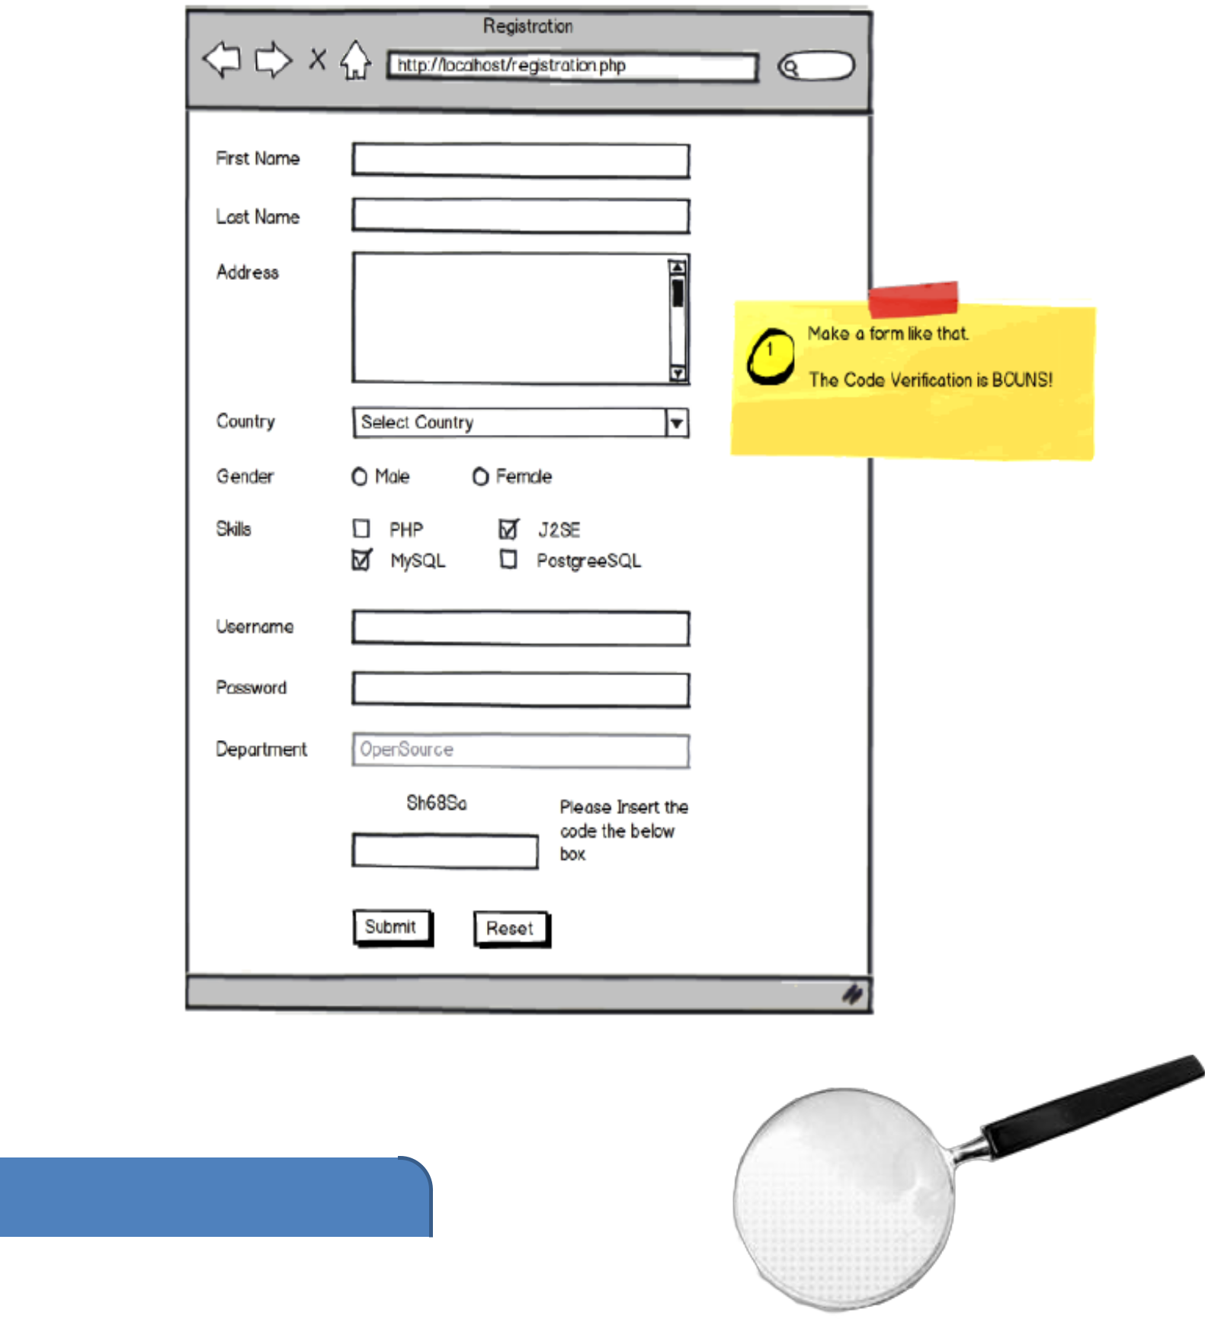7-Create form as following “form.php” page